Arts & Science Program

McMaster University

Arts & Science 2A06
“Social and Political Thought”

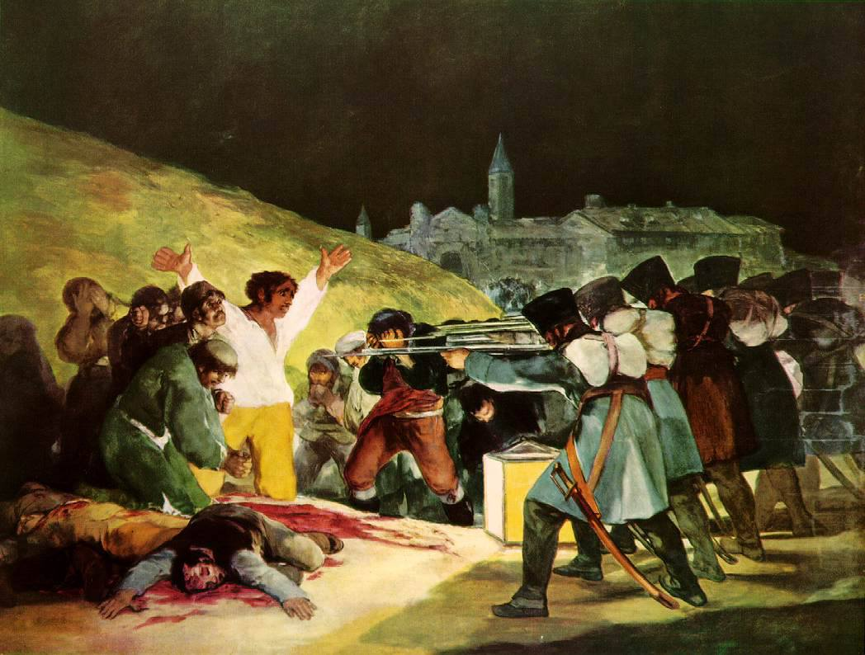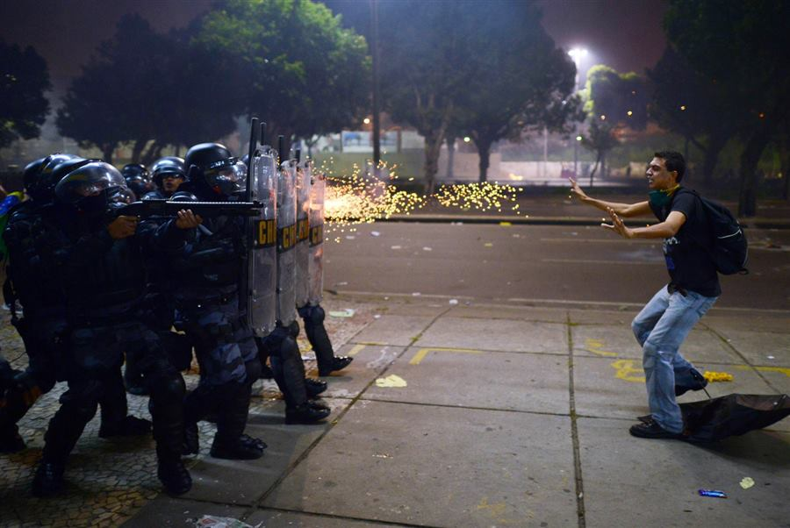
Francisco de Goya, The Third of May 1808 Police fire rubber bullets at protesters in Rio de Janeiro, 20 June 2013

Instructor: Dr. David L. Clark

Class time: Wednesday, 11:30 am - 2:20 pm
Classroom: Term 1: ETB (Engineering Technology Building) 238
Term 2: LRW (LR Wilson Building) 1057

E-mail: dclark@mcmaster.ca

Website: https://hmcwordpress.humanities.mcmaster.ca/dclark/

Office Hours (CNH 210): Term 1: Wednesday 3:00 pm - 4:00 pm
Term 2: Wednesday 3:00 pm - 4:00 pm

NOTE: Since I will be communicating with the class from Avenue, please don’t forget to ensure that your McMaster email is linked to Avenue to Learn. Here’s how to do that: Avenue Mail Instructions.

Teaching Assistant: Elizabeth Bloomfield

E-mail: bloomfie@mcmaster.ca

Office Hours (CNH 220): Term 1: Wednesday 3:00 pm – 4:00 pm
Term 2: Wednesday 3:00 pm – 4: 00 pm

Note: Office hours will be extended later in the term for essay consultation.
To ensure everyone has equal accessibility to office hours, please see either Elizabeth or me for office hour meetings.

The use of philosophy is to sadden. A philosophy that saddens no one,
that annoys no one, is not a philosophy.

--Gilles Deleuze, Nietzsche and Philosophy

How do you convince people to move from the superficial to the substantial,
from the frivolous to the serious, from bling to wrestling with truth and justice
and sorrow and sadness and joy? . . . That’s the first moment of paideia.
That’s the turning of the soul. “The unexamined life is not worth living” . . .
The examined life painful.

--Cornel West, “Paideia: Address to the Students of West Virginia University”

Course Description, Objectives, and Unique Challenges:

Welcome to Social and Political Thought! The course Teaching Assistant, Elizabeth Bloomfield, and I very much look forward to working and learning with you over two semesters. This course description contains a wealth of information about the content, structure, assignments, and unique challenges of SPT. I encourage you to read this outline in its entirety. But let me begin by acknowledging that McMaster University sits on the traditional Territories of the Mississauga and Haudenosaunee Nations, and within the lands protected by the Dish With One Spoon Wampum Agreement.

This course explores the history of critical thinking about the difficulties and possibilities that attend the formation, evolution, revolution, and governance of just communities. Throughout the course, emphasis will be given to a cluster of closely related questions:

What is justice, and what does it mean to strive to create a just society?
What responsibilities and obligations attend social and political life?
What is the role that education, teaching, and learning play in sustaining an equitable society?
How is social and political life imagined differently by different thinkers . . . and why?
In what ways is social and political life formed and deformed by violence, including colonial violence?
To what extent does social and political thought address the question of suffering?
In what ways is social and political thought an affirmation of the irrepressible interdependence of life on Earth?
In what ways is social and political thought complicit with forms of violence, exclusion, and domination?
What are the roles of the university in social and political life? What is the social and political life of the university?
The great social and political theorist, Walter Benjamin, wrote: “There is no document of civilization which is not at the same time a document of barbarism.” In what ways are some of the materials that we study on this course an example of this dual history?

The objective of this course is to provide students with a good working knowledge of a broad range of social and political thinkers and theories in the context of the question of justice and the conflicted meanings of the concept of “the human.” Attention is also given to writing effective essays, i.e., essays that i) have a discernible wager or thesis, ii) make a detailed case for that thesis, and iii) are written with elegance, economy, and correct grammar.

Classes are a mixture of lectures and classroom discussion. The first two hours are taken up with lectures, while a portion of the last hour is, whenever possible, open to discussion and questions. In part of the third hour, students are invited to query and debate the materials and questions at hand. Elizabeth and I invite everyone to contribute to that discussion, which can go in many different directions. For example, some students use it primarily for the purposes of clarification, i.e., to review certain terms or questions explored in lecture. Others may wish to connect what was discussed in lecture to other, related matters—current events, for example, or your own experiences or frustrations with social and political life. It is up to you to develop the discussion portion of the third hour in ways that help enrich and complicate the class’s understanding of the course materials. Don’t forget though to speak to each other during the third hour.

Students are also warmly encouraged to liberate this course from the confines of the formal classroom, and to form independent study groups to discuss and debate the course materials and questions.

Because of the unique subject of the course, there may be moments when we go slightly “off script,” i.e., pause the course to address questions and problems in current events that become too pressing to be ignored. For example, in 2016 the class took time to discuss the election of Donald Trump and, in 2017, the murder of Muslim men at a mosque in Quebec City. The class also took time to discuss student activism surrounding the controversial visit of Professor Jordan Peterson in 2017. This year I have tentatively scheduled a class discussion devoted to one of two issues: either the implications of the recent U.S. Supreme Court decision regarding Roe v Wade or the issue of Climate Change in honour of the Youth Global Climate Strike movement—the Global Climate Strike takes place the same week as our class. A cluster of brief readings will be assigned for this discussion. Let me know which issue you would like to discuss!

Although we have a schedule to which to adhere, and a certain body of work to cover, the course calls for a certain flexibility when necessary. One class towards the end of Term 1, 30 November, described as “Relief Class” in this outline, is designed to give us some manoeuvering room if, for example, certain thinkers, texts, or questions call for more attention and, as a result, we fall slightly behind the posted schedule. Class will still be held on 30 November.

Supplemental readings and substantial Study Notes for specific readings designed to help you consolidate the course material will be provided on Avenue as the course unfolds. Memoranda providing helpful hints on how to write an effective essay, as well as how to prepare for and write an effective midterm examination will also be posted.

It is very important to take good notes during class. Of course, many of you already know how to take good notes and the importance of having notes. Good notes help you prepare for your midterm examinations and essays. The final examination for the course tests your knowledge of the assigned materials in both terms, so having detailed notes from the start of the course will help you as you study for that examination. If you are not in the habit of taking extensive notes in class, I warmly encourage you to start doing so now.

Keeping on top of the readings (and there are a lot of readings in this course) is essential both for your comprehension of the course materials and your understanding of the lectures. Knowing the materials will also contribute significantly to the quality of your remarks during the third hour of the course. Part of what the midterm examinations and the final examination for the course test is whether you have read the materials with care. Try your level best not to rely solely on on-line summaries (many of which are inaccurate or incomplete) of the assigned materials and instead have the courage to wrestle with their actual difficulties, insights, and challenges.

This is a six-unit course, which means that you have lots of room to grow intellectually. You won’t necessarily understand everything, especially on first consideration. The materials that we study call for patience and curiosity and “stick-to-it-ness” (to use a phrase from Cornel West, a professor of African-American studies and theology that we take up in Term 2). You learn how to grapple with social and political thought incrementally by throwing yourself into the process of grappling with it. There are bound to be moments of head-shaking frustration. But also moments of startling illumination. There is a great deal to learn: how to engage the intricacies of the work of some very challenging thinkers, thinkers who write in ways that may well be deeply unfamiliar to you and that make arguments that are insurgent and fundamentally counter-intuitive; how to write a persuasive mid-term examination that focuses on a particular problem or question that is important to this course; and how to write a compelling, thesis-driven and well-argued essay about social and political thought. No one is expecting you to come into your strengths as a student of social and political thought all at once. You are meant to develop these powers and your confidence with the materials over the entirety of the two semesters of the course, learning and improving step by step. There are very few two-semester courses left at McMaster—there’s a good reason why SPT remains one of them! Try your best not to be too surprised if you find yourself struggling, especially in the first term. What matters is remaining curious, focussed, and open to embracing unsettling ideas and new ways of both thinking and writing—all strengths for which Arts & Science students are well known. Along with Elizabeth, I am here to help you along this mazy path.

I’ve cited Cornel West in this outline. Here’s a link to remarks he made to students at Brown University that captures the spirit of social and political thought.

Students from a previous SPT class will be invited to post suggestions on the Avenue coursepage on how they thrived in the course.

In its infinite wisdom, the university has scheduled our class over lunch-time. So I encourage you to bring something nourishing to eat during the class breaks. This is definitely a course in which you want your brain to be properly fueled! If you see me wolfing down something non-nutritious during breaks, feel entirely free to scold me.

What we study

Our course falls into two large movements:

In Term 1 we establish a broad historical context for social and political thought, beginning with the writings of Plato and concluding with Karl Marx. Although we attend to the specific historical contexts informing the assigned readings, the focus will consistently be on the contemporaneity of the work of these thinkers—i.e., how their writings provide an evocative critical language with which to parse the difficulties of social and political life today. In other words, the work we will be considering in Term 1 will not be treated as remote historical artefacts but as living and breathing things that speak to our own worries and hopes for political and social existence. These assigned materials are not without their own problems and limitations—those too will be discussed. The history of social and political thought includes texts and arguments in which we can trace some of the origins of illiberalism, authoritarianism, and colonial and imperial violence. And the same heterogeneous body of work yields arguments that are critical of illiberalism, authoritarianism, and colonial and imperial violence. Our job is to thread our way through this material as best we can.

Among the texts that we consider in Term 1 are: Immanuel Kant’s essay, Toward Perpetual Peace (1795), the precursor to the United Nations Charter; and Mary Wollstonecraft’s A Vindication of the Rights of Woman (1792), the founding text of Anglo-American feminist political thought. We also examine Karl Marx’s Communist Manifesto (1848), his revolutionary denunciation of the wounding powers of capital, John Locke’s Second Treatise of Civil Government (1689), which supplies many of the basic principles for modern liberal democracies as well as colonial power; and Sir Philip Sidney’s A Defense of Poetry (1595), his eloquent plea for humanistic tolerance and learning during a time—the age of Elizabeth I—of intensifying intolerance and dogma. The term begins with a screening and discussion of Astra Taylor’s award-winning documentary, What is Democracy? As you will see, that documentary, like our course, is anchored in the problems and possibilities of ancient Greek social and political thought.

In Term II we explore the work of several contemporary thinkers who address some of the most pressing problems for 21st-century social and political life. We begin this labour through a particular lens: Astra Taylor’s filmed extemporaneous interviews with nine contemporary theorists, which she conducts in different city streetscapes. Astra Taylor is a musician, documentary filmmaker, and political theorist whose recent work has focussed on the destructive effects of student debt. She interviews: Cornel West, a pre-eminent scholar of African-American studies and a theology professor; Avital Ronell, a social theorist of “deconstruction;” Michael Hardt, a political theorist who adapts Marx to the present age; Kwame Appiah, a British-born Ghanian-American cultural theorist and philosopher of cosmopolitanism (i.e., of the problems and the possibilities of being acting as citizens of the world); Slavoj Žižek, a Slovenian political philosopher; Martha Nussbaum, an American feminist political and moral philosopher; Peter Singer, a controversial philosopher of ethics; Judith Butler, an influential theorist of gender and sexuality; and Sunaura Taylor, an artist and disability and animal rights activist. In Examined Life: Philosophy is in the Streets, Taylor emphasizes a crucially important feature of social and political thought, namely the different ways in which it speaks to “the search for meaning and our responsibilities towards others in a world rife with iniquity, persecution, and suffering” (xi). We will consider both her documentary and the book of interviews that accompanies her documentary, Examined Life: Excursions with Contemporary Thinkers. We then explore the definitional problems quickening some of the work of three of the most globally influential social theorists (Michel Foucault, Judith Butler, and Jacques Derrida), focussing on the transgressive questions that contemporary theory raises about knowledge, power, justice and community. In Term II we will also pay attention to the unique ways in which the Holocaust transformed social and political thought deeply and irrevocably, casting a darkly illuminating light on state-sponsored exterminatory violence before, during, and after the rise of Nazism in Europe. To that end, we read The Drowned and the Saved, Primo Levi’s deeply wrenching testamentary account of his experience in the Nazi death-camps. Judith Butler focuses on the politics and the vulnerabilities of what she calls “precarious life.” In influential lectures delivered at the Collège de France, Michel Foucault discusses the history and pervasiveness of what he calls “biopower” in modern life, that is, power devoted to administering subjects through policing their health, productivity, and well-being. We also look at seminars given by Jacques Derrida, who negotiates the particular question of “hospitality”—i.e., the politics and ethics of the encounter with the imperilled stranger. The course concludes by considering the aspirations and capabilities of marginalized communities in the face of systemic, state-sponsored violence. Audra Simpson explores how the Mohawks of Kahnawake create a sovereign identity through acts of refusal, while Glen Sean Coulthard disrupts settler-colonial assumptions about the putative value of political “recognition.” Finally, Ta-Nehisi Coates and Robyn Maynard, among other thinkers involved in or adjacent to the Black Lives Matter movement, reflect upon the formative and deformative powers of race in contemporary America and Canada. But the joyful flourishing of Black and Indigenous lives, respectively, will also be our focus–this, so that suffering doesn’t end up becoming the sole requirement for political agency and political recognition.

No course, not even a six unit course like ours, can embrace anything approaching all the histories of social and political thought. Our focus, especially in the first term, will be the social and political thought to which our 21st-century classroom at McMaster is the direct heir, namely--for better or for worse--a certain European and European-inflected tradition. Emphasis in this course though is consistently given to thinkers who strongly dissent from that tradition and who are in a robustly critical conversation with it precisely because they dwell deep within its confines. Moreover, our course is dedicated to reading the assigned materials both with and against the grain, wrestling not only with their arguments but also with how the same texts contest themselves. But at every point, I welcome insights and questions derived from other traditions. For example, in the past, SPT students have discussed some of the materials that we take up in conjunction with the teachings of Sikhism or with Talmudic wisdom, while others have read our assigned work alongside and athwart forms of Indigenous critique (of the sort that we also study in Term II).

Required Texts:

Much of the required reading material for this course is available via links posted on the course page on Avenue or online at Mills Memorial Library.

Assigned materials not linked on Avenue but available in the bookstore include:

Taylor, Astra. Examined Life: Excursions with Contemporary Thinkers. New York: The New Press, 2009. [This text is also available online at Mills.]

Levi, Primo. The Drowned and the Saved. New York: Vintage, 1989.

Three documentaries also form part of the required material for the course. They will be screened in class. All documentaries are also streamable through the Mills Memorial Library collection.

Examined Life: Philosophy is in the Streets. Dir. Astra Taylor. Sphinx Productions and the National Film Board of Canada, 2008. [88 minutes]

Marx Reloaded. Dir. Jason Barker. Films Noirs/Medea Films, 2011 [52 minutes].

What is Democracy? Dir. Astra Taylor. Zeitgeist Films and the National Film Board of Canada, 2018. [107 minutes]

From time to time, supplemental materials will be added to the coursepage on Avenue: these materials will include Study Guides and scholarly articles designed to help you consolidate the course materials, as well as tips on how to prepare for and write essays and examinations. Please remember that supplemental materials are for use for this course only.

Course Assignments and Weighting:

Midterm examination Term 1: 10% 26 October 11:30 am-12:30 pm [Exam room to be announced.]
Midterm examination Term 2: 10% 1 March 11:30 am-12:30 pm [Exam room to be announced.]
Essay Term 1 (2500 words): 20% Due either 23 November or 7 December [See essay due date policy below]
Essay Term 2 (2500 words): 25% Due either 29 March or 12 April [See essay due date policy below]
Final Examination: 35% Scheduled by the Examinations Office

Essay Due Date and Late Submission Policy:

There are two essays in this course, one in each term. There are two due dates for each essay. You choose which date you would like to submit your essay on.

Essay 1 is due before the start of class, 23 November 2022 or start of class, 7 December 2022.
Essay 2 is due before the start of class, 29 March 2023 or start of class, 12 April 2023.

Essays must be in Word and uploaded to a portal on the Avenue coursepage. Please remember to name your file using your last name, so, for example, Marx.Karl.SPT.Essay.Term1.doc

Essays submitted by the first due date will receive a full marking commentary. Essays handed in by the second due date will be graded exactly the same but without comment. No essays will be accepted after the last class of each term. A grade of zero/F will therefore be assigned to essays not submitted by the 7 December 2022 and 12 April 2023 final due dates, respectively.

Since the essay is weighted heavily in this course, students are encouraged not to leave working on this assignment until late in the term. Suggested essay topics will be posted on Avenue. You are strongly encouraged to discuss and develop your essay topic with either me or the course T.A., Elizabeth. Extra office hours will be added to regular office hours at those points in the term when students need to be discussing their essays. Writing a persuasive essay for SPT is a demanding assignment and will in all likelihood mean jettisoning some old researching and writing habits, some of which may have served you well in the past, and instead learning new techniques. –A steep learning curve, but one that almost all SPT students ascend wonderfully! You will be asked to write an essay that is governed by a highly focussed opening wager or thesis, often the hardest part of writing an essay, and then makes a compelling case for that wager through analysis and argumentation.

What I bring to our class:

Beyond exploring the some of the histories of social and political thought, as well as discussing the ways in which we differently struggle today in the wake of those histories, my objective in this course is threefold: 1) that undergraduate students from diverse backgrounds and holding diverse perspectives, experiences, intellectual histories, and interpretive frameworks flourish; 2) that the diverse learning requirements of students be addressed both in and out of the course; and 3) that the diversity that students bring to this course be treated as a resource and strength. I intend to create a teaching and learning setting that honours diversity along a number of axes, including: race, gender, sexuality, disability, age, socioeconomic status, ethnicity, nationality, and religion. Please know that your suggestions and criticisms are encouraged and appreciated. I am always interested in improving the effectiveness of the course for you and for other students. My commitment is to be flexible and accommodating wherever and whenever possible.

Given the challenging nature of the material discussed in class, it is important that we work together in an atmosphere of trust and mutuality in the classroom. My goal is to foster an educational setting in which every student is able to hear and respect each other. I encourage rigorous discussion and debate, and anticipate that at certain points there will be strong disagreement. Social and political thought is nothing if not the subject of disputation. But it is important that our class remain a space of respect, intellectual curiosity and generosity. I also anticipate that some of the material in this course will evoke strong and indeed discomfiting feelings. We will be considering past and present cultural trauma, oppression, and violence—some of which some of you will have experienced and endured first-hand. We will be discussing past and present scenes of awful devastation and extermination. Some of you may at times feel a sense of loss, dismay, and bewilderment. I certainly do. I ask that you remain respectful of those feelings in others and that you try your best to be cognizant of your own. But as I hope this class demonstrates, a rigorous consideration of the social and political origins of our present-day is also an opportunity to act and think anew about what it means to create a habitable, equitable, just, and flourishing planet.

If at any point you feel like the quality of your work in the course is being unduly affected by your experiences inside or outside of class, please do not hesitate to reach out to me. I am always ready to lend an understanding ear and to help in whatever way that I can. If you need assistance, you can also access several useful and compassionate resources at the Student Wellness Centre.

It is important to acknowledge that I do not share a small selection social and political texts from anything approaching a neutral place. Nor are any of the texts that we study written from a neutral place. Far from it. I am trained specifically in Continental theory and philosophy, with an emphasis on what is sometimes called “deconstruction.” That is to say, my research background and teaching practice point toward questions of suffering, justice, community, and the conflicted meanings of “the human,” especially as these questions are asked in European or European-inflected social and political thought. An array of research methodologies, theoretical frameworks, interpretive strategies, and world-views that fall under the aegis of what is called “deconstruction” has taught me to attend closely to the ways in which that body of thought is generatively at odds with itself, shaken to the core by revealing fault-lines, inconsistencies, “unarticulated presuppositions” (as Cornel West would say), and unresolved worries. I am a white cis-gendered man, from a professional household and a Canadian citizen born on Turtle Island--and so I have accrued many of the unearned privileges that come with being the person that I am. And yet, as luck would have it, around your age I also endured periods of homelessness, illness, and extreme poverty, and had to make my way in the world without the support of a family. But--and this for me is the key part--I was never alone because I was lifted up by loving friends and inspiring teachers. Since becoming a professor, I have had the pleasure of teaching thousands of students in five universities in two countries. I bring all of that experience into our classroom. One of the things I look forward to every year is hearing your own stories and thus understanding a bit more about where you are coming from and where you are heading.

Activated by the Black Lives Matter movement, let us imagine what it would be like to hold our Wednesday class in what Fred Moten and Stefano Harney call “the abolitionist university” (“the university: last words” 3), by which they mean the university that attempts to put an end to that version of itself that is complicit in structures and practices of violence against racialized communities. I am hardly alone in this ongoing process of reflection and call to resistance and to community-building. McMaster University’s Department of English and Cultural Studies, of which I am a long-time member, for example, has recently established a new “Program Learning Outcome” (PLO), i.e., a shared objective which all courses strive to embrace in meaningful manner. That PLO reads as follows: “Recognizing the impact of historical and ongoing oppression and resistance in literary, cultural, and educational institutions, engage actively in projects and conversations that challenge oppression and foster transformative change toward more just, diverse and equitable universities, communities and worlds.” Our course responds to this call in a number of ways. These include a sustained focus on: the origins and nature of structures of oppression; the challenges facing the formation of a just community; the severely destructive problems associated with claiming to identify what constitutes the “properly” human (which always includes the disavowal of those who have been deemed to be “less than human.”) A question that we will explore through the course is: in what ways is the Canadian 21st century heir to forms of injustice and oppression explored, confronted, and perpetrated in previous centuries? Moreover, it is important to this course that we concede that the university is not a neutral space in which to consider the question of violence and oppression—universities and educational institutions more broadly can be complicit in exclusionary practices. Let’s make sure we make that fact a subject of our discussion as well. Social and political thinkers offer a wellspring of concepts, figures, and arguments with which to conduct this discussion.

Students interested in my view of the current and future university are encouraged to consult my essay, “Abolish the University: Build the Sanctuary Campus.” Many of you may recall reading this essay for last fall’s Agora event.

I also invite you to listen to two University of Victoria Bounce podcasts hosted by Professor Rebecca Gagan, “Waving, Not Drowning,” in which Professor Gagan and I discuss our own struggles as students and our hopes for the present and future of education.

Provisional Lecture Schedule

Sept 7 Prefatory Remarks + What is Democracy? [Screening of the abridged version of Astra Taylor’s documentary.]
+ Readings posted on Avenue + class discussion]
14 Plato, The Republic [Introductory remarks: Book I, II, IV]
21 Plato, The Republic [Book V, VII]
28 Class discussion: Implications of the Roe vs Wade Decision OR Global Climate Strike

Oct 5 Sir Philip Sidney, Defense of Poetry
12 Mid-term recess (no class)
19 John Locke, Second Treatise of Civil Government [selections]
26 Mid-term Examination [Room to be announced] (no class after the examination)

Nov 2 Immanuel Kant, Toward Perpetual Peace
9 Immanuel Kant, Toward Perpetual Peace
16 Mary Wollstonecraft, A Vindication of the Rights of Woman [pages 21-141]
23 Karl Marx, The Communist Manifesto + Capital [selections]; John Bellamy Foster, “Absolute Capitalism” [First due date for Essay 1]
30 Relief Class

Dec 7 Karl Marx, The Communist Manifesto + Capital [selections] + Marx Reloaded [documentary screening] [Last day to submit Essay 1]

Jan 11 Examined Life: Philosophy is in the Streets (documentary screening + discussion)
18 Examined Life: Excursions with Contemporary Thinkers
25 Examined Life: Excursions with Contemporary Thinkers

Feb 1 Michel Foucault, Society Must Be Defended [Lectures 1,2,3,4 and ll]
8 Michel Foucault, Society Must Be Defended [Lectures 1,2,3,4 and 11]
15 Judith Butler, Precarious Life [Selections]
22 Mid-term recess (no class)

March 1 Mid-term examination [Room to be announced] (no class after examination)

8 Primo Levi, The Drowned and the Saved
15 Primo Levi, The Drowned and the Saved
22 Jacques Derrida, Of Hospitality
29 Black Lives Matter (selected readings by various thinkers, including Ta-Nahesi Coates’ Letter to My Son and Robyn Maynard’s, "Arrested (In)justice," from Policing Black Lives: State Violence in Canada from Slavery to the Present ) [First due date for Essay 2]

April 5 Black Lives Matter (selected readings by various thinkers)
12 Audra Simpson, Mohawk Interruptus: Political Life Across the Borders of Settler States [selections] + Glenn Sean Coulthard, Red Skin, White Masks: Rejecting the Colonial Politics of Recognition [Selections] [Last day to submit Essay 2]

Final Examination Review Session: I am happy to host a review session—arranged by the class--outside of regular class hours.

A Few Important Notes About the Course

1. Class cancellations:

In the unlikely event of a class cancellation, students will be notified via email through Avenue.

2. E-mail policy and protocols:

McMaster University policy requires email communication between students, instructors and T.A.’s to be conducted using McMaster email accounts. This policy protects confidentiality and confirms the identity of the student.

Don’t forget to ensure that your McMaster email is linked to Avenue to Learn. Here’s how to do that: Avenue Mail Instructions.

Since we are in a professional working environment, all e-mails to your instructor or T.A. must be written in full sentences (i.e. no point form, no text-messaging short form), and must contain a subject line that includes the course designation, “2A06” or “SPT.” All e-mails must contain some form of salutation and valediction (i.e., “Dear Dr. Clark,” “Dear Elizabeth” and “Yours sincerely,” respectively, or equivalents). Receipt of all e-mails from your instructor or your T.A. must be acknowledged. For example, a simple “Thank you for getting back to me” will often suffice. Be professional, courteous, and respectful in all communications.

Be assured that your instructor or T.A. will respond to your e-mail in a timely manner. Do not assume that you will hear back immediately.

3. Copies of Essays:

Keep a copy of the essays that you submit for the course.

4. Regrading or re-assessment of grades:

The assignment of essay, midterm, and final examination grades is the result of a fair and rigorous evaluation process. Elizabeth and I are happy to discuss your grades with you and to help you understand how to learn from our assessment of your work in the course. We treat the assessment of your work as an opportunity to learn. Normally, though, assignments will not be regraded.

5. MSAF and REQUESTS FOR RELIEF FOR MISSED ACADEMIC TERM WORK

Please note that if you MSAF an assignment you will still be required to complete that assignment. Assignments will not be deleted from the course or grades reweighted.

Students should familiarize themselves with the MSAF policy before requesting relief for missed academic term work. See important information about MSAF on the Requests page of the Arts & Science website.

6. Course evaluation:

Students will be invited to evaluate the course towards the conclusion of the Term 2.

7. Cell phones, sending and receiving texts, and internet connections:

All mobile device notifications (ringers, etc.) must be turned off during class. As a sign of your commitment to creating a professional and courteous teaching and learning environment, you are required to refrain from texting, emailing, playing games on-line, surfing, etc. in class. Using the internet to consult materials posted on Avenue is of course permitted and encouraged.

8. What to do if you miss class:

If you miss a class the best thing to do is to borrow notes from several of your classmates. Elizabeth and I will not be able to recapitulate missed lectures and discussions in office hours or on email.

SENATE-APPROVED ADVISORY STATEMENTS

ACADEMIC INTEGRITY
You are expected to exhibit honesty and use ethical behaviour in all aspects of the learning process. Academic credentials you earn are rooted in principles of honesty and academic integrity. It is your responsibility to understand what constitutes academic dishonesty.
Academic dishonesty is to knowingly act or fail to act in a way that results or could result in unearned academic credit or advantage. This behaviour can result in serious consequences, e.g. the grade of zero on an assignment, loss of credit with a notation on the transcript (notation reads: “Grade of F assigned for academic dishonesty”), and/or suspension or expulsion from the university. For information on the various types of academic dishonesty please refer to the Academic Integrity Policy, located at https://secretariat.mcmaster.ca/university-policies-procedures- guidelines/.
The following illustrates only three forms of academic dishonesty:
- plagiarism, e.g. the submission of work that is not one’s own or for which other credit has been obtained.
- improper collaboration in group work.
- copying or using unauthorized aids in tests and examinations.

AUTHENTICITY / PLAGIARISM DETECTION
Some courses may use a web-based service (Turnitin.com) to reveal authenticity and ownership of student submitted work. For courses using such software, students will be expected to submit their work electronically either directly to Turnitin.com or via an online learning platform (e.g. A2L, etc.) using plagiarism detection (a service supported by Turnitin.com) so it can be checked for academic dishonesty.
Students who do not wish their work to be submitted through the plagiarism detection software must inform the Instructor before the assignment is due. No penalty will be assigned to a student who does not submit work to the plagiarism detection software. All submitted work is subject to normal verification that standards of academic integrity have been upheld (e.g., online search, other software, etc.). For more details about McMaster’s use of Turnitin.com please go to www.mcmaster.ca/academicintegrity.

COURSES WITH AN ONLINE ELEMENT
Some courses may use online elements (e.g. e-mail, Avenue to Learn (A2L), LearnLink, web pages, capa, Moodle, ThinkingCap, etc.). Students should be aware that, when they access the electronic components of a course using these elements, private information such as first and last names, user names for the McMaster e-mail accounts, and program affiliation may become apparent to all other students in the same course. The available information is dependent on the technology used. Continuation in a course that uses online elements will be deemed consent to this disclosure. If you have any questions or concerns about such disclosure please discuss this with the course instructor.

ONLINE PROCTORING
Some courses may use online proctoring software for tests and exams. This software may require students to turn on their video camera, present identification, monitor and record their computer activities, and/or lock/restrict their browser or other applications/software during tests or exams. This software may be required to be installed before the test/exam begins.

CONDUCT EXPECTATIONS
As a McMaster student, you have the right to experience, and the responsibility to demonstrate, respectful and dignified interactions within all of our living, learning and working communities. These expectations are described in the Code of Student Rights & Responsibilities (the “Code”). All students share the responsibility of maintaining a positive environment for the academic and personal growth of all McMaster community members, whether in person or online.
It is essential that students be mindful of their interactions online, as the Code remains in effect in virtual learning environments. The Code applies to any interactions that adversely affect, disrupt, or interfere with reasonable participation in University activities. Student disruptions or behaviours that interfere with university functions on online platforms (e.g. use of Avenue 2 Learn, WebEx or Zoom for delivery), will be taken very seriously and will be investigated. Outcomes may include restriction or removal of the involved students’ access to these platforms.

ACADEMIC ACCOMMODATION OF STUDENTS WITH DISABILITIES
Students with disabilities who require academic accommodation must contact Student Accessibility Services (SAS) at 905-525-9140 ext. 28652 or sas@mcmaster.ca to make arrangements with a Program Coordinator. For further information, consult McMaster University’s Academic Accommodation of Students with Disabilities policy.

REQUESTS FOR RELIEF FOR MISSED ACADEMIC TERM WORK
In the event of an absence for medical or other reasons, students should review and follow the Policy on Requests for Relief for Missed Academic Term Work.

ACADEMIC ACCOMMODATION FOR RELIGIOUS, INDIGENOUS OR SPIRITUAL OBSERVANCES (RISO)
Students requiring academic accommodation based on religious, indigenous or spiritual observances should follow the procedures set out in the RISO policy. Students should submit their request to their Faculty Office normally within 10 working days of the beginning of term in which they anticipate a need for accommodation or to the Registrar's Office prior to their examinations. Students should also contact their instructors as soon as possible to make alternative arrangements for classes, assignments, and tests.

COPYRIGHT AND RECORDING
Students are advised that lectures, demonstrations, performances, and any other course material provided by an instructor include copyright protected works. The Copyright Act and copyright law protect every original literary, dramatic, musical and artistic work, including lectures by University instructors. The recording of lectures, tutorials, or other methods of instruction may occur during a course. Recording may be done either by the instructor for the purpose of authorized distribution or by a student for the purpose of personal study. Students should be aware that their voice and/or image may be recorded by others during the class. Please speak with the instructor if this is a concern for you.

EXTREME CIRCUMSTANCES
The University reserves the right to change the dates and deadlines for any or all courses in extreme circumstances (e.g., severe weather, labour disruptions, etc.). Changes will be communicated through regular McMaster communication channels, such as McMaster Daily News, A2L and/or McMaster email.

NOTES FOR ALL ARTS & SCIENCE COURSES
- Some of the statements above refer to a “Faculty Office”; please note that the Arts & Science Program Office serves in this capacity.
- It is the responsibility of students to check their McMaster email regularly. Announcements will be made in class, via A2L, and/or via the course email distribution list.
- For additional information regarding requests for accommodation, relief for missed term work (e.g. MSAF), deferred examinations, etc., students should read carefully the Requests and Resources pages on the Arts & Science Program website.

